Day in the life of Grace Normington
After a night of combing the streets Grace returns home to Mint Ridge and her half of a duplex. She was lucky to find one in Mint Ridge, where it was quiet with low crime and a short walk to both the School she works at and the zoo.

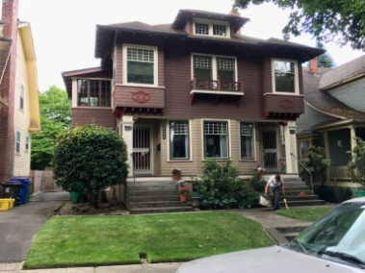
When arriving home she finds the morning THE HUDSON CITY AGENDA paper left for her. It’s a leftwing paper through-and-through, and makes no bones about it. When questioned about his lack of objectivity, publisher Robert Dawes says, “We’ve got freedom of the press in this country — so you’re free to go get your own goddamn press and stop telling me how to use mine. Her good friend, Michael Matthews is a Janitor for the newspaper and next door neighbor. She is pretty sure he has an interest in her.
Not having to sleep is sometimes a blessing for a teacher as it can give plenty of time for grading papers or catching up on the latest new bulletin of her church written by Juniper Cross, leader of The Satanic Temple in her region, which Grace is a part of and considers Juniper one of her closest friend.
She makes sure she has done her hygiene routine, has secured her hair into a bun so the kids can't pull it, and is wearing a thick long sleeve shirt to cover her tattoos. She drinks from the thermos that holds her drip coffee from home. (8$ a cup for what is half milk is too much). She gets into her blue beetle and heads off to work.
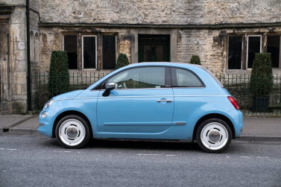
Arriving at the school, she parks her car and makes her way to the entrance. School buses are unloading and she spots her best bestie Marie Pilkerton, one of the Elementary School bus drivers. They share a lot of views and have a great time hanging out when they can.


The day begins with the little mob of thirty first graders charging into the room, full of energy.

The day play out and all the teachers meet up in the teachers lounge.
Nancy, the other first grade teacher, sees Grace and asks, “Grace, we are going out for drinks and dinner want to come along?”
Grace doesn't do drugs and drinks only on special occasions, responds, "That sounds like a great idea! I'm always up for a night out."
“Who's driving?,” Nancy asks, “ I will leave mine here. I think the brakes are going.”
"I'll drive." Grace volunteers.
Tim, Carol, Nancy and Grace, head out to the parking lot and pile into her car.

